**Insert PGadmin4**

-- Database: Practical

CREATE TABLE Student

(

MatricNo int NOT NULL,

StudentName varchar(255),

Semester int,

Session varchar(255),

Organization varchar(255),

PRIMARY KEY(MatricNo)

);

INSERT INTO Student (MatricNo, StudentName, Semester, Session, Organization)

VALUES ('254454','Ramesh','7','2018/2019','SOC');

INSERT INTO Student (MatricNo, StudentName, Semester, Session, Organization)

VALUES ('253982','Kavshik','7','2018/2019','SOC');

INSERT INTO Student (MatricNo, StudentName, Semester, Session, Organization)

VALUES ('253055','Khilan','7','2018/2019','COB');

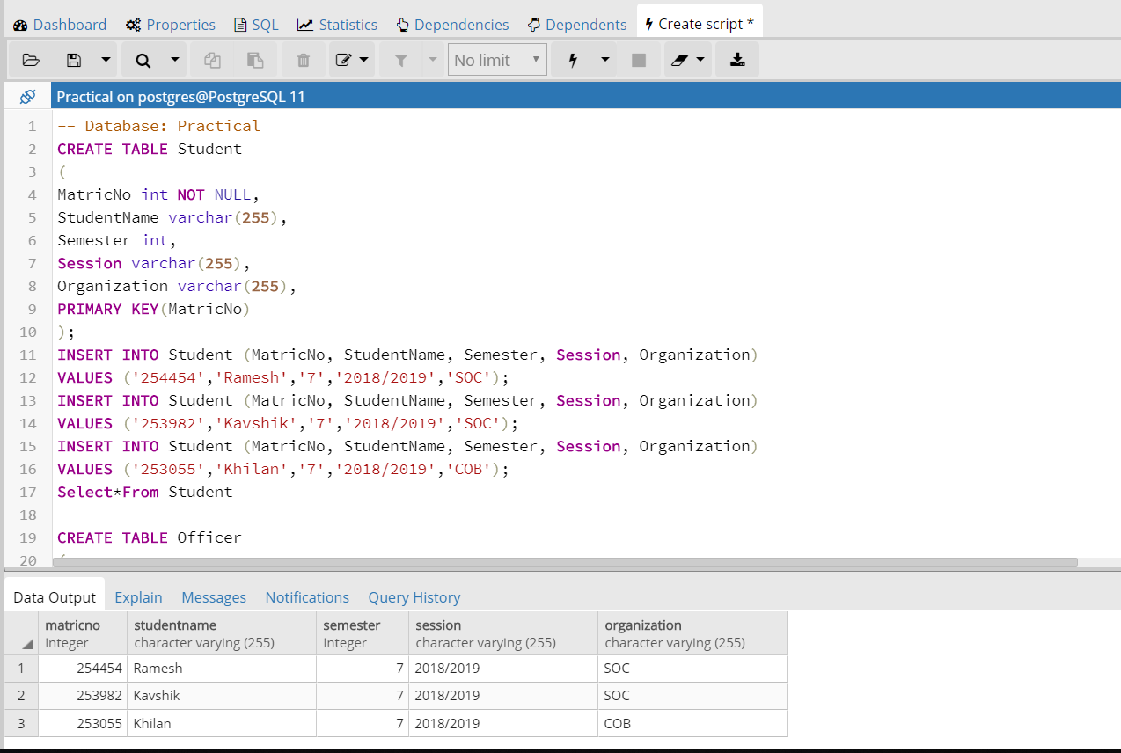

CREATE TABLE Officer

(

Officer_ID int NOT NULL,

OfficerName varchar (255),

Date varchar(255),

MatricNo int,

PRIMARY KEY(Officer_ID),

FOREIGN KEY (MatricNo) REFERENCES Student(MatricNo)

);

INSERT INTO Officer

VALUES ('001','Ali','15/11/2018','254454');

INSERT INTO Officer

VALUES ('002','Siti','16/11/2018','253982');

INSERT INTO Officer

VALUES ('003','Ahmad','18/11/2018','253055');

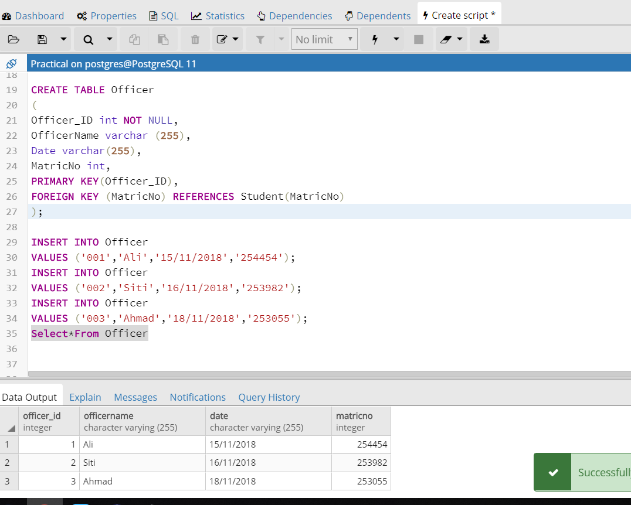

CREATE TABLE SectionA

(

SectionA_ID int NOT NULL,

Knowledge float,

VerbalCommunication float,

WrittenCommunication float,

SocialSkill_Responsibility float,

Values_Attitudes_Professionalism float,

LifelongLearning float,

TotalA float,

MatricNo int,

PRIMARY KEY(SectionA_ID),

FOREIGN KEY (MatricNo) REFERENCES Student(MatricNo)

);

INSERT INTO SectionA (SectionA_ID, Knowledge, VerbalCommunication, WrittenCommunication, SocialSkill_Responsibility,Values_Attitudes_Professionalism,LifelongLearning,TotalA,MatricNo)

VALUES ('6001','2.75','3','2.25','2.375','3','2.25','15.625','254454');

INSERT INTO SectionA (SectionA_ID, Knowledge, VerbalCommunication, WrittenCommunication, SocialSkill_Responsibility,Values_Attitudes_Professionalism,LifelongLearning,TotalA,MatricNo)

VALUES ('6002','2.25','2.67','2.25','2.375','3','1.875','14.42','253982');

INSERT INTO SectionA (SectionA_ID, Knowledge, VerbalCommunication, WrittenCommunication, SocialSkill_Responsibility,Values_Attitudes_Professionalism,LifelongLearning,TotalA,MatricNo)

VALUES ('6003','2','3.67','1.5','1.5','2.33','1.6875','12.6875','253055');

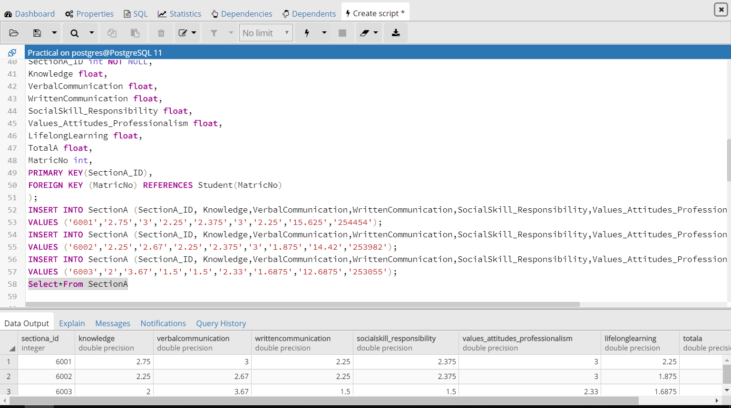

CREATE TABLE SectionB

(

SectionB_ID int NOT NULL,

Practical_Project_Presentation float,

ProblemSolving float,

TotalB float,

MatricNo int,

PRIMARY KEY(SectionB_ID),

FOREIGN KEY (MatricNo) REFERENCES Student(MatricNo)

);

INSERT INTO SectionB

VALUES ('7001','6.39','7.5','13.89','254454');

INSERT INTO SectionB

VALUES ('7002','5.83','6.25','12.08','253982');

INSERT INTO SectionB

VALUES ('7003','7.78','5.625','13.405','253055');

select*from SectionB;

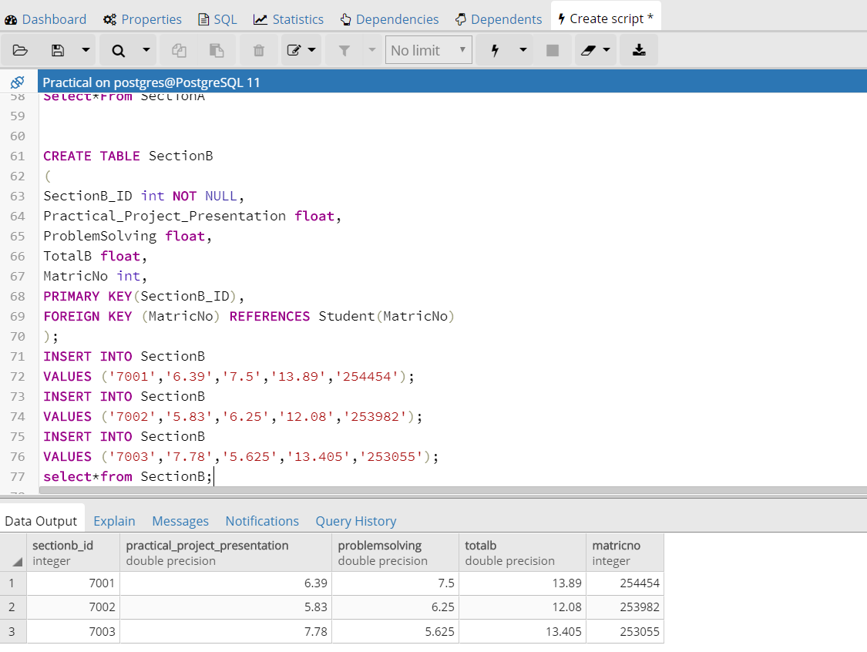

CREATE TABLE SectionC

(

SectionC_ID int NOT NULL,

Performance_of_student varchar(255),

Skillslacking varchar(255),

Expected_skills varchar(255),

Recruited varchar(255),

MatricNo int,

PRIMARY KEY(SectionC_ID),

FOREIGN KEY (MatricNo) REFERENCES Student(MatricNo)

);

INSERT INTO SectionC

VALUES ('8001','good','good','good','good','254454');

INSERT INTO SectionC

VALUES ('8002','good','good','good','good','253982');

INSERT INTO SectionC

VALUES ('8003','good','good','good','good','253055');

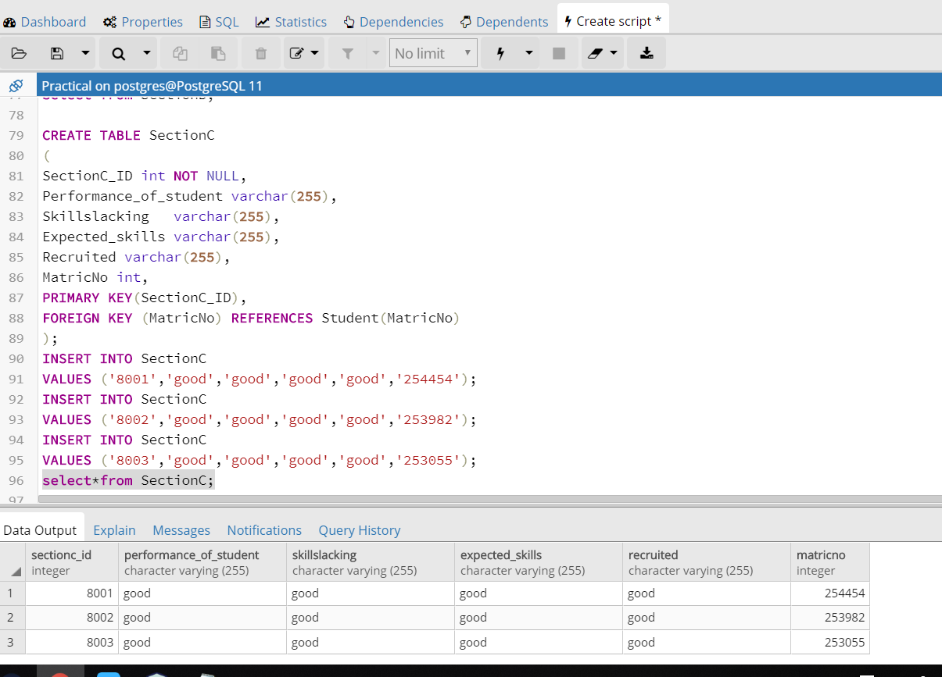

CREATE TABLE EvaluationForm

(

FormNo int NOT NULL,

MatricNo int,

GrandTotal float,

PRIMARY KEY(FormNo),

FOREIGN KEY (MatricNo) REFERENCES Student(MatricNo)

);

INSERT INTO EvaluationForm

VALUES ('1001','254454','29.515');

INSERT INTO EvaluationForm

VALUES ('1002','253982','26.5');

INSERT INTO EvaluationForm

VALUES ('1003','253055','26.0925');

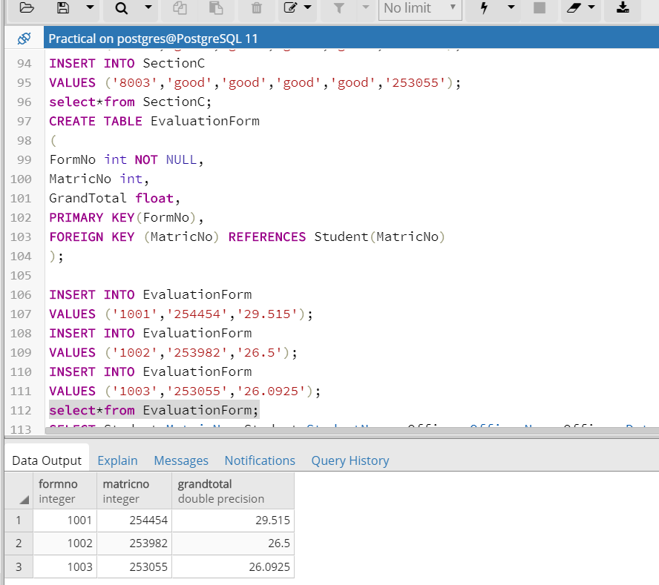

SELECT Student.MatricNo, Student.StudentName, Officer.OfficerName,Officer.Date,EvaluationForm.FormNo,SectionA.TotalA,SectionB.TotalB,EvaluationForm.GrandTotal

FROM Student

INNER JOIN Officer ON Student.MatricNo = Officer.MatricNo

INNER JOIN EvaluationForm ON Student.MatricNo = EvaluationForm.MatricNo

INNER JOIN SectionA ON Student.MatricNo = SectionA.MatricNo

INNER JOIN SectionB ON Student.MatricNo = SectionB.MatricNo

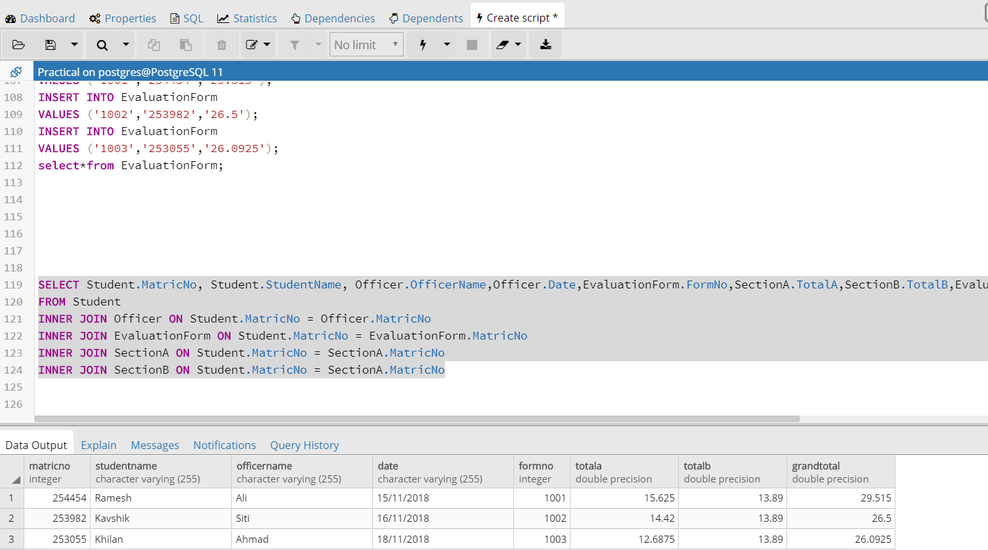

**Read NetBeans**

package stid_postgresqljdbc;

import java.sql.*;

import java.sql.Connection;

import java.sql.DriverManager;

import java.sql.ResultSet;

import java.sql.Statement;

public class PostgreSQLJDBC {

public static void main( String args[] ) {

Connection c = null;

Statement stmt = null;

try {

Class.forName("org.postgresql.Driver");

c = DriverManager

.getConnection("jdbc:postgresql://localhost:5432/Practical",

"postgres", "zhanyi0328");

c.setAutoCommit(false);

System.out.println("Opened database successfully");

stmt = c.createStatement();

ResultSet rs = stmt.executeQuery( "SELECT * FROM Student;" );

while ( rs.next() ) {

int MatricNo = rs.getInt("MatricNo");

String StudentName = rs.getString("StudentName");

int Semester = rs.getInt("Semester");

String Session = rs.getString("Session");

String Organization = rs.getString("Organization");

System.out.println( "MatricNo= " + MatricNo );

System.out.println( "StudentName = " + StudentName );

System.out.println( "Semester = " + Semester );

System.out.println( "Session = " + Session );

System.out.println( "Organization = " + Organization );

System.out.println();

}

rs.close();

stmt.close();

c.close();

} catch ( Exception e ) {

System.err.println( e.getClass().getName()+": "+ e.getMessage() );

System.exit(0);

}

System.out.println("Operation done successfully");

}

}

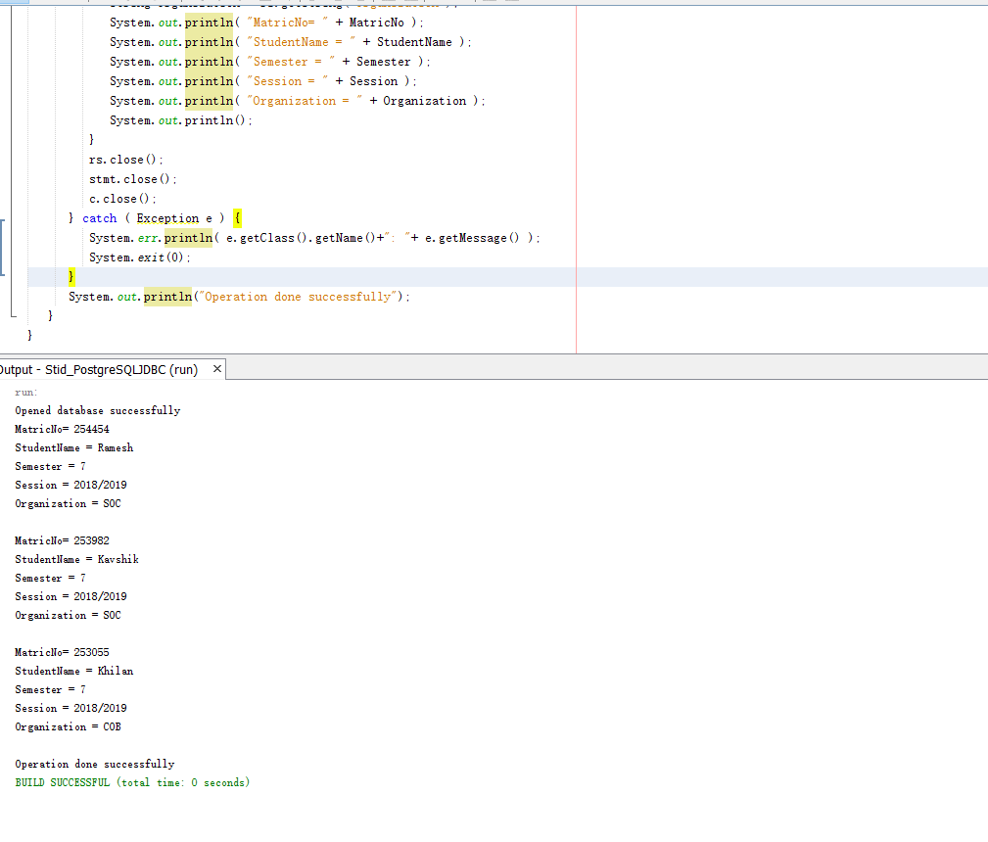

**Update NetBeans**

package stid_postgresqljdbc;

import java.sql.*;

import java.sql.Connection;

import java.sql.DriverManager;

import java.sql.ResultSet;

import java.sql.Statement;

public class PostgreSQLJDBC {

public static void main( String args[] ) {

Connection c = null;

Statement stmt = null;

try {

Class.forName("org.postgresql.Driver");

c = DriverManager

.getConnection("jdbc:postgresql://localhost:5432/Practical",

"postgres", "zhanyi0328");

c.setAutoCommit(false);

System.out.println("Opened database successfully");

stmt = c.createStatement();

String sql = "UPDATE EvaluationForm set GrandTotal = 30 where FormNo=1001;";

stmt.executeUpdate(sql);

c.commit();

ResultSet rs = stmt.executeQuery( "SELECT * FROM EvaluationForm;" );

while ( rs.next() ) {

int FormNo = rs.getInt("FormNo");

int MatricNo = rs.getInt("MatricNo");

float GrandTotal = rs.getFloat("GrandTotal");

System.out.println( "FormNo = " + FormNo );

System.out.println( "MatricNo = " + MatricNo );

System.out.println( "GrandTotal = " + GrandTotal );

System.out.println();

}

rs.close();

stmt.close();

c.close();

} catch ( Exception e ) {

System.err.println( e.getClass().getName()+": "+ e.getMessage() );

System.exit(0);

}

System.out.println("Operation done successfully");

}

}

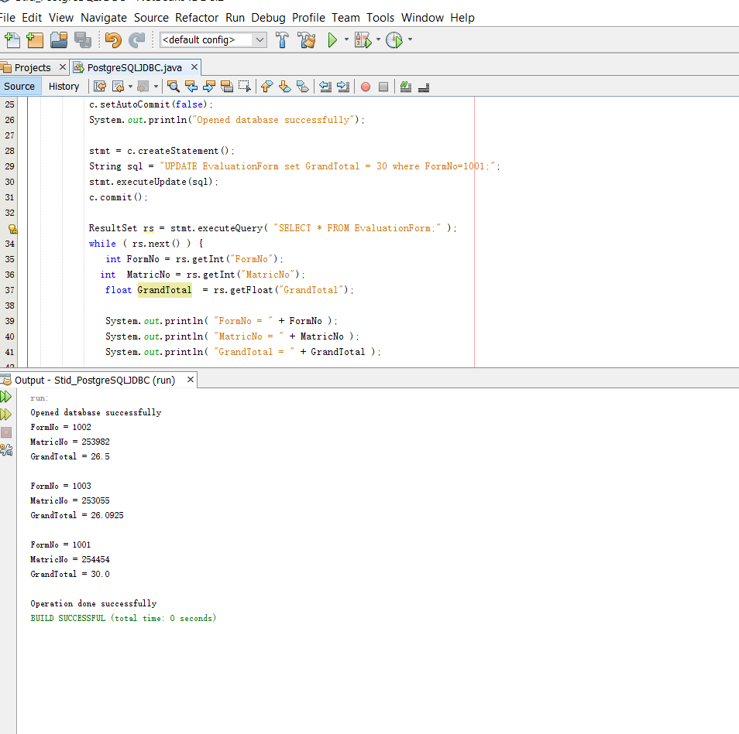

**Delete NetBeans**

package stid_postgresqljdbc;

import java.sql.*;

import java.sql.Connection;

import java.sql.DriverManager;

import java.sql.ResultSet;

import java.sql.Statement;

public class PostgreSQLJDBC {

public static void main( String args[] ) {

Connection c = null;

Statement stmt = null;

try {

Class.forName("org.postgresql.Driver");

c = DriverManager

.getConnection("jdbc:postgresql://localhost:5432/Practical",

"postgres", "zhanyi0328");

c.setAutoCommit(false);

System.out.println("Opened database successfully");

stmt = c.createStatement();

String sql = "DELETE from Officer where Officer_ID = 001;";

stmt.executeUpdate(sql);

c.commit();

ResultSet rs = stmt.executeQuery( "SELECT * FROM Officer;" );

while ( rs.next() ) {

int Officer_ID = rs.getInt("Officer_ID");

String OfficerName = rs.getString("OfficerName");

String Date = rs.getString("Date");

int MatricNo = rs.getInt("MatricNo");

System.out.println( "Officer_ID = " + Officer_ID );

System.out.println( "OfficerName = " + OfficerName );

System.out.println( "Date = " + Date );

System.out.println( "MatricNo = " + MatricNo );

System.out.println();

}

rs.close();

stmt.close();

c.close();

} catch ( Exception e ) {

System.err.println( e.getClass().getName()+": "+ e.getMessage() );

System.exit(0);

}

System.out.println("Operation done successfully");

}

}

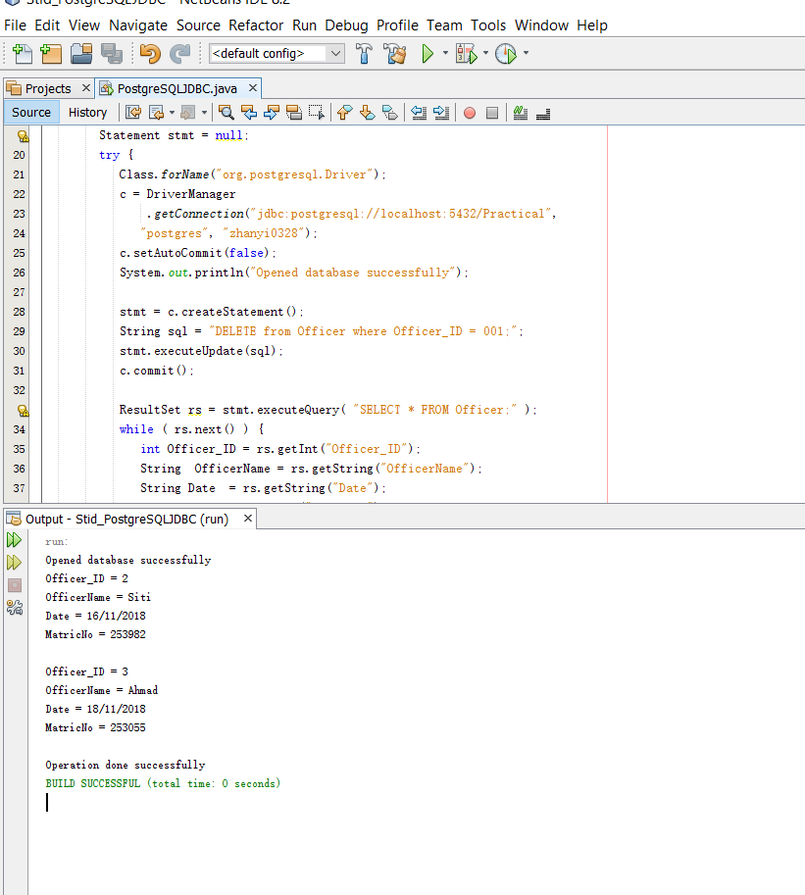

**Write NetBeans**

package stid_postgresqljdbc;

import java.sql.Connection;

import java.sql.DriverManager;

import java.sql.Statement;

public class PostgreSQLJDBC {

public static void main(String args[]) {

Connection c = null;

Statement stmt = null;

try {

Class.forName("org.postgresql.Driver");

c = DriverManager

.getConnection("jdbc:postgresql://localhost:5432/Practical",

"postgres", "zhanyi0328");

c.setAutoCommit(false);

System.out.println("Opened database successfully");

stmt = c.createStatement();

String sql = "INSERT INTO Student (MatricNo,StudentName,Semester,Session,Organization) "

+ "VALUES ('234589', 'Paul', 4, '2018/2019','SOC' );";

stmt.executeUpdate(sql);

stmt.close();

c.commit();

c.close();

} catch (Exception e) {

System.err.println( e.getClass().getName()+": "+ e.getMessage() );

System.exit(0);

}

System.out.println("Records created successfully");

}

}

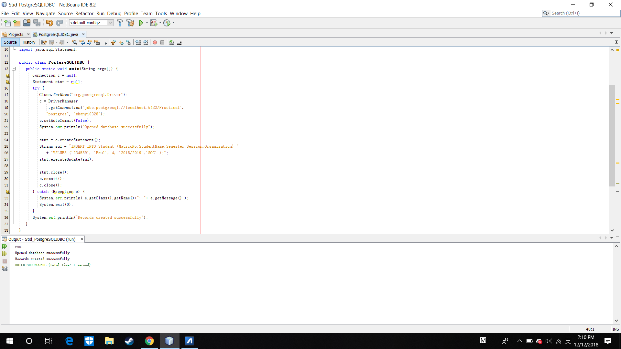

Display After Insert New Data

